Informatics Coding Assessment

Name: __Jonathon Raney___________

Date: ___05/29/2024_______________

Instructions:

Please use either R or Python to code the following. When you have completed the questions, attach the code to the end of the document as well as your rendering of the graphs. Please include comments within the code to describe each step.

There are three questions to this assessment. If you cannot complete question 1, please refer to the graphs in question1 provided for question 2 and 3.

1. **Using the datasets in the zip file, please recreate the three graphs shown below.**

Graph 1

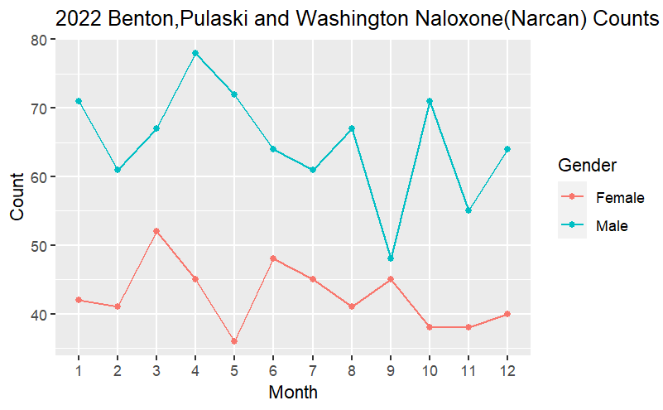

Graph 2 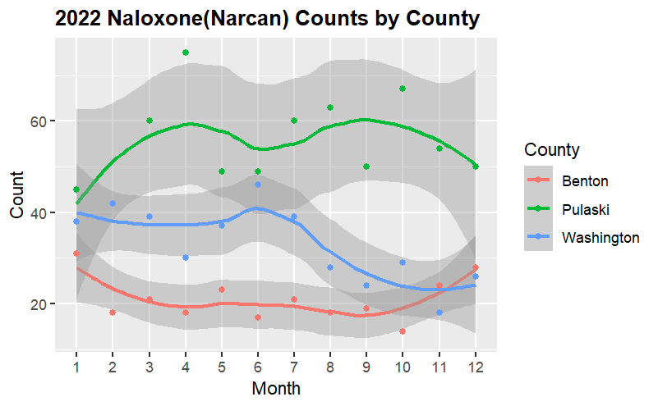

Graph 3

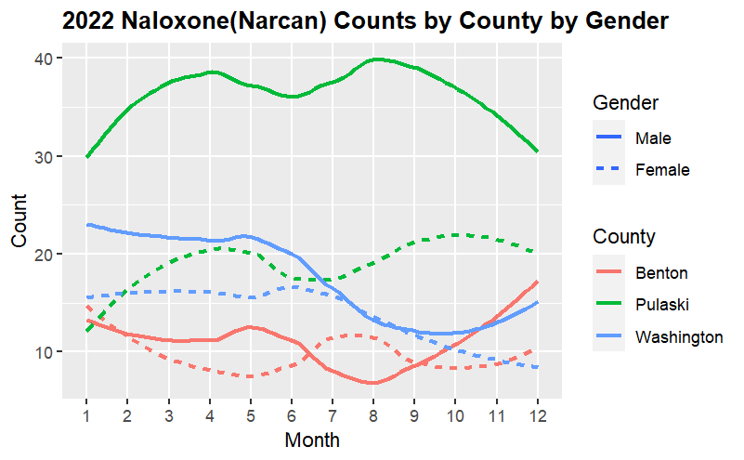

1. **What changes would you make to any of the three graphs (if any)?**

**I would change the scale of the x axis to end at exactly 12 instead of 12.5 and to begin at 1. I would account for multiple dosages given to same patient. I would record the data more accurately in regards to gender. If the gender of the patient matters, I would make sure to record it. For my graphs I removed duplicate records IE different doses given to the same patient at the same time. This slightly skewed the accuracy of the counts but the same general trends in the data were maintained. Another factor affecting counts was the lack of gender recording for some cases. In the future, I would separately plot the races and ages of patients to see if the data provides any additional insight. When presented with the problem of visualizing data in the future, I would search for a more elegant coding solution.**

1. **Discuss why you think these graphs might be impactful to the ADH.**

**These graphs would be impactful to the ADH for several reasons. The most glaring reason is the disease and drug monitoring. The federal government requires that diseases and potentially dangerous drugs be monitored and statistically reported. Narcan use falls into the category of potentially dangerous drugs or epidemic because of its counteractive effects in the case of an opioid overdose. In recent years, opioid abuse has become so prevalent in the U.S. that it has been labeled an epidemic. The increased death rates have become a problem and the government must be blamed. In conclusion, the Narcan usage statistics can be recorded to help the government know when and where to fight the opioid epidemic. Also, in case the government runs out of Narcan we can know where it all went. The data could be used to train a predictive model of Narcan use to know where and when EMS need to be in the future and predict other things. The graphs could be used as an example of how to apply data visualizations to any other recorded data sets of interest to the ADH. No data presentation is complete without these graphs and software tools.**



